Comparative analysis of graduate and postdoctoral trends across U.S. universities: insights from research funding, enrollment, and fellowship support.

This report presents a comparative analysis of Old Dominion University (ODU) with 11 universities exhibiting high growth rates in research expenditures and graduate program support, alongside the New Mexico Institute of Mining and Technology—a university that, despite previously ranking below ODU, surpassed it in R&D spending between 2021 and 2022. By examining these institutions’ ranking, average annual growth, R&D investments, and key research areas (as summarized in Table 1), the report explores how diverse investment strategies contribute to their growth trajectories.

ODU stands out for its specialized research focus on industrial engineering, health sciences, and biomedical sciences, in contrast to other universities with broader research portfolios that encompass fields like computer science and social sciences. ODU’s graduate enrollment trends indicate recent growth in science programs, yet stable or declining figures in engineering and health fields, differing from the consistent growth seen at peer institutions. Additionally, ODU’s funding structure heavily relies on alternative support sources and personal resources, with minimal fellowship opportunities, whereas other universities often provide robust assistantships and fellowships. This reliance may impact ODU’s ability to attract top-tier graduate talent. Through detailed case analyses, this report provides a comprehensive view of ODU’s unique strengths and highlights areas where it diverges from and could potentially align with its high-growth peers.

Table 1. Average Yearly Growth and R&D Investments by Institution and Strong Areas of Research

|  |  |  |  |
| --- | --- | --- | --- |
| **Institution (Rank)** | **Avg_Yearly_Growth** | **R&D grow 2021-2022 (Dollar in Thousand)** | **Strong Area of investment** |
| Baseline  ODU (191) | - | 62,332 - 64,877 | Industrial and manufacturing engineering- Health sciences- Biological and biomedical sciences |
| New Mexico Institute of Mining and Technology (176) | - | 28,745- 89,900 | Engineering not elsewhere classified |
| Wichita State U. (109) | 16% | 192,042 - 261,519 | Aerospace, aeronautical, and astronautical engineering |
| Uniformed Services U. of the Health Sciences (105) | 10% | 384,490 - 277,240  (Decreased in 2022) | Health sciences - Psychology |
| U. Louisiana, Lafayette (132) | 10% | 181,400 - 205,201 | Biological and biomedical sciences - Computer Science |
| U. Texas, San Antonio (151) | 10% | 145,362 - 147,629 | Biological and biomedical sciences- Computer Science-Non-S&E |
| Northeastern U. (115) | 9% | 211,342 - 231,607 | Computer Science - Electrical, electronic, and communications engineering |
| George Mason U. (117) | 9% | 214,207 - 230,068 | Social sciences – Economics-Law |
| Georgia State U. (125) | 9% | 206,472 - 215,908 | Biological and biomedical sciences- Non-S&E(Education) |
| Temple U. (98) | 9% | 299,778 - 301,395 | Health sciences- Life sciences, not elsewhere classified |
| U. Notre Dame (102) | 8% | 240,324 - 280,604 | Biological and biomedical sciences- Aerospace, aeronautical, and astronautical engineering- Non-S&E |
| Florida International U. (101) | 8% | 246,075 - 281,665 | Biological and biomedical sciences- Engineering |
| U. Dayton (128) | 7% | 191,228- 211,494 | Metallurgical and materials engineering- Industrial and manufacturing engineering |

# Comparison of Old Dominion University with Peer Institutions: A Structured Analysis

Old Dominion University (ODU) stands out in several ways when compared to other research universities, based on distinct research focus areas, enrollment trends, postdoctoral opportunities, and funding structures. This analysis highlights ODU’s unique characteristics and contrasts them with the trends observed at other institutions.

## Specialized Research Focus

ODU’s research emphasis is distinct, centering on **industrial and manufacturing engineering**, **health sciences**, and **biological and biomedical sciences**. This focus provides ODU with a specific niche:

* **Industrial and Manufacturing Engineering**: ODU invests heavily in this field, differentiating itself from institutions that may prioritize broader engineering fields like aerospace or electrical engineering.
* **Health Sciences and Biomedical Research**: While many universities also invest in health sciences, ODU combines this with a strong emphasis on applied industrial research, positioning it uniquely among its peers.

In contrast, other research-intensive universities typically have broader research portfolios, often spanning computer science, social sciences, and environmental sciences. This diversification allows them to attract a wider variety of federal and private funding sources, but ODU’s more focused approach may allow it to develop specialized expertise in these selected fields.

## Graduate Enrollment Patterns

ODU’s graduate enrollment trends reveal some unique patterns:

* **Science Graduate Programs**: ODU experienced a notable decline in science graduate enrollments between 2014 and 2018, followed by a period of growth leading up to 2022. This recent recovery suggests renewed interest or additional resources dedicated to science programs.
* **Engineering Graduate Programs**: Engineering enrollment at ODU has stabilized at a lower level compared to its early years, indicating either a decrease in demand or limited institutional focus.
* **Health Graduate Programs**: Enrollment in health-related graduate programs remains low and stable, suggesting limited expansion or interest in this area relative to other fields.

Other research universities tend to have more robust and consistent growth across all major fields, particularly in **engineering** and **health sciences**, where national demand has been strong. Many of these institutions show continuous increases in engineering enrollment, reflecting a higher demand and broader emphasis on engineering disciplines compared to ODU.

## Postdoctoral Opportunities by Field

ODU exhibits fluctuating trends in postdoctoral positions, with a distinct emphasis on science postdocs:

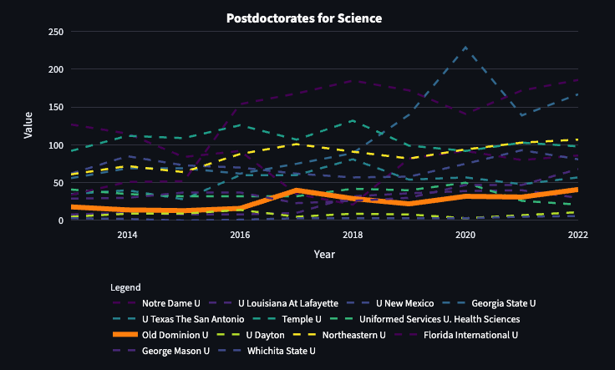

* **Science Postdoctoral Positions**: ODU has seen an increase in science postdoctoral opportunities, with a peak around 2022. This growth signals strong, albeit inconsistent, support for postdoctoral research in scientific fields.
* **Engineering Postdoctoral Positions**: Engineering postdocs at ODU are minimal and have nearly disappeared by 2022, suggesting a diminishing focus on postdoctoral research in engineering.
* **Health Postdoctoral Positions**: Health postdocs are virtually non-existent at ODU, indicating limited or no dedicated resources for postdoctoral research in health-related fields.

In comparison, other research institutions generally offer more stable and growing opportunities for postdoctoral researchers across multiple fields, especially in high-demand areas like engineering and health sciences. The reduced postdoc positions in engineering and health at ODU contrast with the trends at these universities, where postdoctoral positions are often seen as essential for advancing research and training new scientists.

## Funding Structure for Graduate Students

ODU’s funding structure for graduate students is characterized by a heavy reliance on **alternative funding sources** and **personal resources**:

* **Other Types of Support and Personal Resources**: ODU relies significantly on alternative support sources and self-funding. The proportion of graduate students depending on personal resources and “other support” types has been increasing, indicating that institutional support is supplemented substantially by external or self-funded sources.
* **Research and Teaching Assistantships**: While ODU does offer research and teaching assistantships, these have remained at relatively stable but modest levels, with minimal growth over the years.
* **Fellowships**: Fellowship support is minimal at ODU, with consistently low numbers across all years, indicating limited availability of competitive funding options for students.

In contrast, larger research universities typically provide a wider array of **fellowships** and **assistantships**, particularly through federal and institutional funding. These universities often support a substantial portion of their graduate students through assistantships and fellowships, which reduces the financial burden on students and minimizes reliance on personal resources. The heavy reliance on alternative funding and self-funding at ODU suggests budget constraints or limited institutional capacity to provide competitive graduate funding.

## Availability of Fellowship Support

One of the most noticeable differences at ODU is the minimal availability of **fellowships**:

* ODU’s fellowship funding remains consistently low across all years. This limited access to fellowship-based funding means that fewer graduate students receive competitive, merit-based financial support that is common at many other research institutions.

Other universities with strong research funding typically have established fellowship programs that support graduate education in science, engineering, and health disciplines. This fellowship support is often vital for attracting high-caliber students and enhancing the institution’s research reputation. ODU’s limited fellowship availability makes it more reliant on external funding or personal resources, which could impact its competitiveness in attracting top graduate talent.

**Summary of Key Differentiators for Old Dominion University**

In conclusion, Old Dominion University exhibits several distinct characteristics compared to peer institutions:

* **Specialized Research Focus**: ODU’s emphasis on industrial and manufacturing engineering, along with health sciences, sets it apart from other institutions with broader research priorities.
* **Unique Enrollment Patterns**: ODU’s recent increase in science graduate enrollment and stabilized engineering enrollment contrast with other universities that show steady or strong growth across major fields like engineering and health sciences.
* **Fluctuating Postdoctoral Trends**: ODU’s inconsistent postdoctoral positions in science and the minimal presence in engineering and health differ from more stable postdoctoral trends seen at other institutions.
* **Alternative Funding Dependence**: ODU’s graduate funding model, heavily reliant on personal resources and alternative support, contrasts with the more balanced funding models of larger universities with substantial fellowships and assistantships.
* **Limited Fellowship Support**: The lack of robust fellowship funding at ODU is a notable distinction, impacting its ability to attract and retain top-tier graduate students compared to institutions with strong fellowship programs.

These differences underscore ODU’s niche strengths and highlight areas where it diverges from other research institutions, reflecting a unique approach to research, enrollment, and funding support.

## Individual Analysis

### Plot 1: Graduate Students by Category (Science, Engineering, Health)

* Science:
  + Science graduate enrollment begins around 400 students in 2014, then declines to around 300 by 2018. After this period, it experiences a recovery, reaching approximately 400 students by 2022.
  + This trend indicates fluctuations, with a recent increase, suggesting renewed interest or resources in science programs.
* Engineering:
  + Engineering enrollment starts at 200 students in 2014 and gradually decreases, stabilizing around 150 students from 2018 to 2022.
  + The steady decline and stabilization at a lower level suggest decreasing emphasis or demand in engineering graduate programs.
* Health:
  + Health enrollment remains consistently low, fluctuating slightly around 50-100 students across the years, indicating limited growth or focus in health graduate studies.

### Plot 2: Postdoctorates by Category (Science, Engineering, Health)

* Science:
  + Science postdoctoral positions show variability, starting at about 20 positions in 2014, peaking at 40 in 2022, with notable fluctuations in between.
  + The pattern of growth followed by declines and recoveries suggests unstable but increasing support for science postdoctoral roles.
* Engineering:
  + Engineering postdocs are minimal, fluctuating between 5-20 positions with a notable peak around 2019, after which it decreases to nearly 0 by 2022.
  + This reflects limited focus on engineering postdoctoral positions, with a recent reduction.
* Health:
  + Health postdoctoral positions are consistently close to 0 across all years, indicating minimal or no focus on health postdocs.

### Plot 3: Funding Sources (Fellowships, Research Assistantships, Teaching Assistantships, Other Support, Personal Resources)

* Research Assistantships:
  + Research assistantships show a fluctuating trend, starting around 250 students in 2014, peaking in 2018, and then stabilizing close to 300 by 2022.
  + The overall trend suggests consistent support with moderate growth in research funding.
* Personal Resources:
  + Personal resources show steady growth from around 250 in 2014 to nearly 300 by 2022, indicating increasing reliance on self-funding.
* Teaching Assistantships:
  + Teaching assistantships begin at 200 students, decline to around 100 by 2018, and show minor increases towards 2022. This trend suggests a decrease in availability or demand for teaching assistantships over time.
* Other Types of Support:
  + “Other types of support” is the largest funding source, showing growth from 250 in 2014 to over 300 in recent years, with fluctuations in between. This indicates stable but variable reliance on alternative support types.
* Fellowships:
  + Fellowships are consistently minimal, remaining close to 0 across all years, indicating limited fellowship opportunities.

# New Mexico Institute of Mining and Technology

## Plot 1: Graduate Students by Category (Science, Engineering, Health)

* Science:
  + The Science category consistently has the highest enrollment among graduate students, peaking around 2016 at approximately 1100 students. However, there is a sharp decline in 2018, dropping to around 700 students. This notable drop suggests a significant shift or decrease in student interest or enrollment capacity during that period.
  + After 2018, there is a strong recovery, with numbers exceeding 1200 by 2022, marking the highest point in the timeline. This rebound indicates a renewed or heightened interest in science programs, which could be due to internal program adjustments or external factors.
* Engineering:
  + Engineering enrollment is relatively stable across the years but shows a sharp decline from 2016 to 2018, dropping from around 400 to 200 students. This trend suggests a temporary decrease in interest or resources within the Engineering program during these years.
  + From 2018 onward, there’s a steady increase, reaching close to 500 students by 2022. This gradual rise points to a recovery phase, potentially indicating efforts to boost program enrollment or increasing attractiveness of engineering fields.
* Health:
  + Health enrollment has remained the lowest compared to Science and Engineering. The trend is flat from 2014 to 2018, maintaining minimal growth. However, starting in 2018, there’s a noticeable increase, reaching over 300 by 2022.
  + This upward trajectory in Health enrollment post-2018 may indicate a rising appeal of health-related graduate programs, aligning with observed changes in the other fields but at a smaller scale.

* Science:
  + Postdoctoral positions in Science exhibit fluctuations, peaking around 2014 with close to 80 positions, followed by a gradual decline that bottoms out around 2018. This downward trend might reflect reduced funding or fewer opportunities during that period.
  + A recovery in 2020 brings the numbers back up to approximately 70 positions, though there’s a slight drop again by 2022. This indicates a variable but generally strong interest in Science postdocs, with peaks and troughs likely reflecting shifting resources or research opportunities.
* Engineering:
  + Engineering postdoc numbers remain consistently low throughout the timeline, between 20-30 positions. The limited variability suggests stable demand but relatively low availability or interest in postdoctoral roles within Engineering.
  + A minor decrease toward 2022 could hint at slight shifts away from postdoctoral positions in Engineering, potentially as graduates opt for industry positions rather than postdoc roles.
* Health:
  + Health postdoc positions start with modest numbers around 2014 but show a steep decline from 2016 onward, stabilizing around 10 positions by 2022. This sustained low level suggests that postdoctoral roles in Health are relatively limited and have not experienced any significant resurgence.

* Other Types of Support:
  + The “Other types of support” category is the most variable, with substantial peaks in 2016, 2020, and 2022 (reaching over 1400 in 2022). This extreme variability indicates that this category is influenced by intermittent or large-scale funding injections, potentially from special grants or initiatives.
* Research and Teaching Assistantships:
  + Research Assistantships are relatively stable, staying around 400-500 over the years, while Teaching Assistantships are slightly lower, around 300-400. This consistent trend highlights the reliance on assistantship positions as steady funding sources for graduate students, with minor increases indicating gradual expansions or adjustments in resource allocation.
  + Both assistantship types see minor increases around 2022, suggesting that the institution may have expanded these support roles in response to enrollment changes or increased student needs.
* Fellowships:
  + Fellowships remain notably low across all years, staying close to 0, which indicates that fellowship funding is either scarce or very competitive at this institution. The absence of fellowship growth suggests limited institutional or external investment in this type of student support.
* Personal Resources:
  + Personal funding is consistently low but shows a slight increase around 2022. This small rise might indicate an increase in self-funded students, which could be related to rising costs or limited availability of institutional support, leading students to rely more on personal or family resources.

# Wichita State University

## Plot 1: Graduate Students by Category (Science, Engineering, Health)

* Science:
  + The Science category starts with moderate enrollment, peaking around 2014 at about 400 students. After this peak, there’s a steady decline, reaching approximately 200 students by 2018. This trend suggests a drop in interest or availability in science graduate programs during these years.
  + A dramatic increase occurs after 2020, with enrollment skyrocketing to over 1200 students by 2022. This sharp rise could indicate a recent surge in interest or a substantial expansion of the Science graduate programs.
* Engineering:
  + Engineering enrollment is fairly stable, beginning close to 300 students in 2014 but showing a slight decline and reaching a low of about 150 students around 2018.
  + After 2018, Engineering experiences a gradual increase, reaching around 400 students by 2022. This recovery, though slower than in Science, indicates a positive trend toward growth.
* Health:
  + Health graduate enrollment is very low and remains nearly flat across the timeline, staying close to 0. This minimal enrollment suggests that Health programs are either very limited at Wichita State or have not been a focal point for graduate studies.

## Plot 2: Postdoctorates by Category (Science, Engineering, Health)

* Science:
  + The number of Science postdoctoral positions is initially low, with about 3 positions around 2014 but then dropping to 0 by 2016. This absence suggests a lack of support or demand for postdocs in Science during these years.
  + Starting in 2018, there is a steady increase in Science postdoctoral positions, reaching about 6 positions by 2022. This growth, while modest, shows a renewed commitment to postdoctoral support in the Science category.
* Engineering:
  + Engineering postdoc positions are virtually nonexistent, starting with only a single position around 2014 and disappearing entirely until 2022, when it reappears with 1 position. The low and sporadic count indicates that postdoc opportunities in Engineering are extremely limited.
* Health:
  + Health postdoctoral positions are consistently at 0 across all years. This suggests a lack of a postdoctoral framework or minimal research activity in Health at Wichita State University.

## Plot 3: Funding Sources (Fellowships, Research Assistantships, Teaching Assistantships, Other types of Support, Personal Resources)

* Personal Resources:
  + Personal resources show a remarkable trend, beginning with 600 students in 2014 and gradually declining until about 2020. After 2020, personal resource funding sees an explosive increase, exceeding 1200 students by 2022. This pattern suggests that more students are relying on personal funding, particularly in recent years.
* Other Types of Support:
  + Other types of support follow a similar trajectory to personal resources, with high values in 2014 (around 600) but decreasing steadily to around 200 by 2020. This decline suggests that external or alternative funding options diminished over time.
  + The numbers remain low around 2022, indicating limited recovery in these support sources compared to personal funding.
* Research and Teaching Assistantships:
  + Both Research and Teaching Assistantships are stable but low. Research Assistantships hover between 50-100 students throughout the years, while Teaching Assistantships remain consistently just below 50.
  + This stability suggests that assistantships are a limited but steady source of support, without any significant expansion to meet rising demand.
* Fellowships:
  + Fellowships remain close to 0 across all years, indicating that fellowships are either highly limited or not actively offered as a support option at Wichita State University.

# Uniformed Services U. of the Health Sciences

## Plot 1: Graduate Students by Category (Science, Engineering, Health)

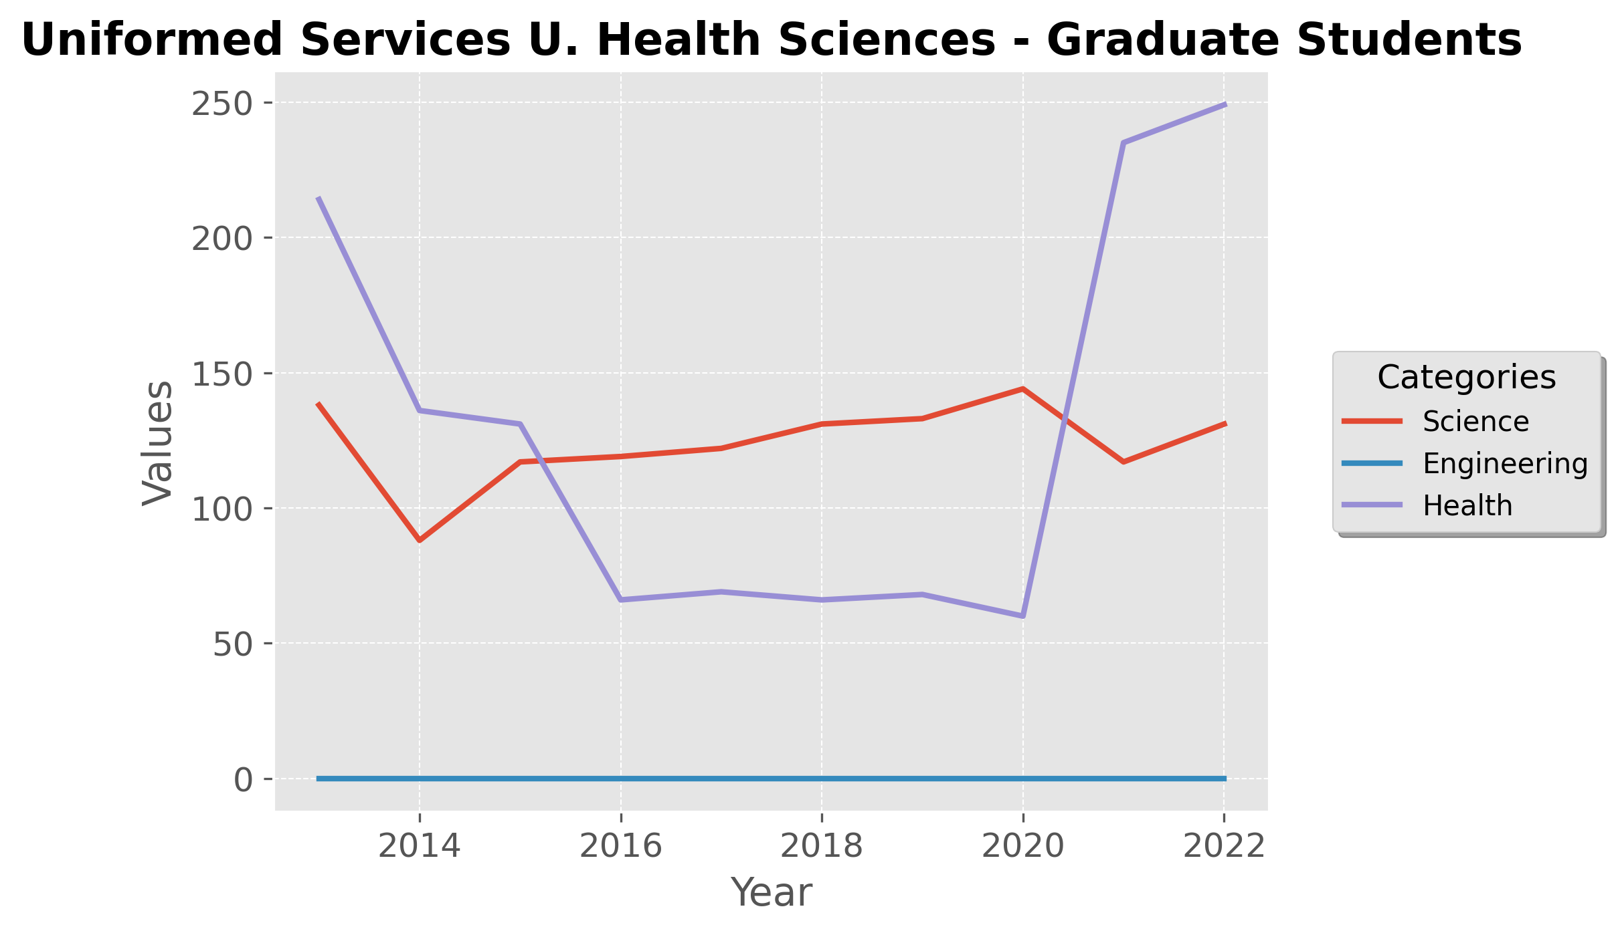

* Science:
  + Enrollment in Science starts around 100 students in 2014 with a slight drop in the following years, stabilizing between 100-150 students from 2016 to 2020.
  + There is a slight decrease after 2020, maintaining a value just below 150 by 2022, indicating stable but modest interest in science graduate programs over the years.
* Engineering:
  + Engineering shows no recorded enrollment throughout the timeline, suggesting either a lack of an engineering graduate program or a complete absence of students in this category.
* Health:
  + Health graduate student enrollment begins high, around 200 students in 2014, but declines sharply, reaching approximately 50 students by 2016. It remains at this low level until 2020.
  + A dramatic increase occurs after 2020, with enrollment spiking to over 250 students by 2022, indicating a recent surge in interest or resources dedicated to health-related graduate studies.

## Plot 2: Postdoctorates by Category (Science, Engineering, Health)

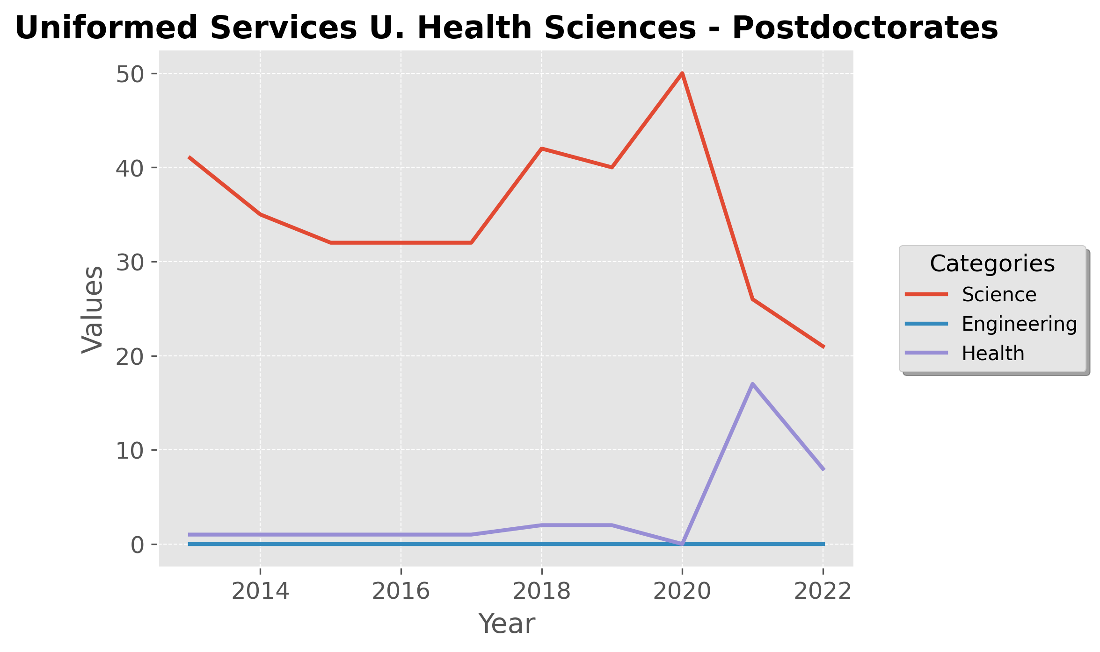

* Science:
  + Science postdoctoral positions remain relatively stable at around 40 from 2014 to 2018 but experience a slight increase, peaking at 50 in 2020.
  + After 2020, there is a sharp decline, reducing the number of Science postdocs to below 20 by 2022. This drop suggests a decrease in available postdoctoral opportunities or a reduction in the number of science postdocs.
* Engineering:
  + Engineering postdoc positions are non-existent across all years, similar to the graduate student trends, indicating no activity or availability for postdoctoral roles in Engineering.
* Health:
  + Health postdoctoral roles are absent until 2020, when they appear briefly with about 10 positions. However, these positions decrease in 2022, showing only a few opportunities for postdoctoral work in Health.

## Plot 3: Funding Sources (Fellowships, Research Assistantships, Teaching Assistantships, Other Support, Personal Resources)

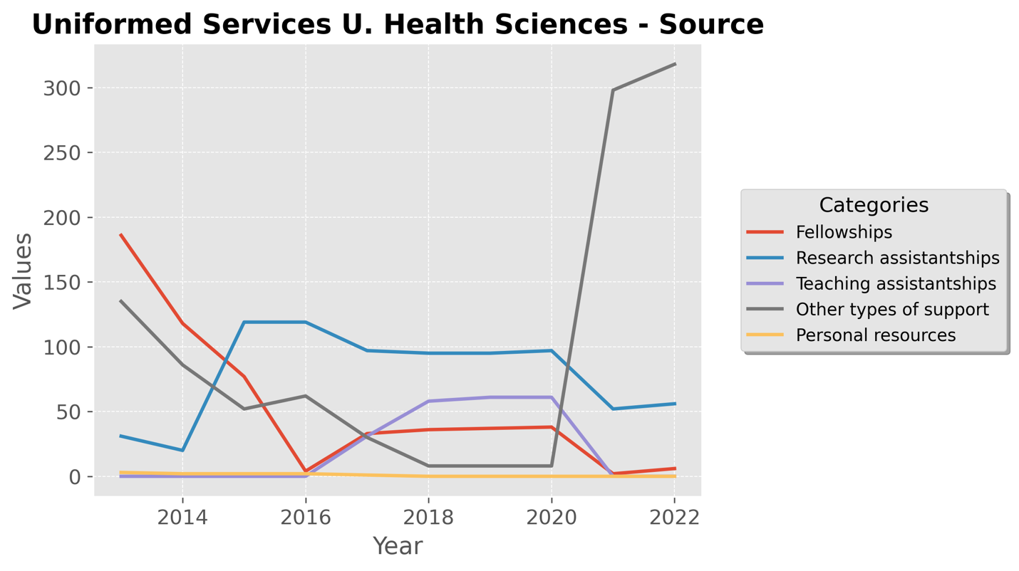

* Fellowships:
  + Fellowship funding starts high, with about 200 students in 2014, but shows a consistent decline over the years, reaching nearly 0 by 2020. This trend suggests a reduction or reallocation in fellowship resources over time.
* Research Assistantships:
  + Research assistantships begin around 50 students in 2014 and experience a gradual decline, stabilizing near 30 by 2020. This stability at a lower level implies steady but limited funding through research assistantships.
* Teaching Assistantships:
  + Teaching assistantships remain consistently low, hovering just above 0 across all years, indicating very limited support through teaching roles.
* Other Types of Support:
  + Other types of support start at around 150 students in 2014 but show a rapid decline, reaching nearly 0 by 2016. However, there is a resurgence in 2022, spiking dramatically to over 300 students, suggesting a recent, substantial funding injection.
* Personal Resources:
  + Personal resources remain minimal across all years, with little to no reliance on personal funding, implying that students may receive other forms of institutional support or rely less on personal funding.

# University Texas San Antionio

## Plot 1: Graduate Students by Category (Science, Engineering, Health)

* Science:
  + Enrollment in Science remains relatively stable, starting at around 650 students in 2014 with a slight decline, reaching just below 600 by 2018. From 2018 onwards, it increases gradually, peaking around 750 students in 2022.
  + This steady rise in recent years suggests sustained interest or increased resources allocated to science programs.
* Engineering:
  + Engineering begins with a high of about 400 students in 2014 but shows a clear declining trend, dropping to approximately 200 students by 2020. This decrease might indicate a reduced focus or shifting interest in engineering fields.
  + There’s a slight stabilization around 2020-2022, indicating that the downward trend has leveled off.
* Health:
  + Health enrollment remains low throughout the years, fluctuating around 50 students. The consistent low numbers suggest a limited scope or low demand for health graduate programs at the university.

## Plot 2: Postdoctorates by Category (Science, Engineering, Health)

* Science:
  + Science postdoctoral positions vary significantly over time, with peaks and valleys. Starting at about 40 positions in 2014, there’s a decline, followed by a steep increase, reaching a peak of 80 positions in 2018.
  + After 2018, there’s a gradual decline, settling around 50 positions by 2022. This pattern may indicate variability in funding or changing priorities in postdoctoral research support.
* Engineering:
  + Engineering postdocs are consistently low, fluctuating between 10-20 positions across the years. This stability at a low level implies limited postdoctoral opportunities in engineering compared to science.
* Health:
  + Health postdoctoral positions are almost negligible, hovering just above 0 throughout the period, reflecting minimal or no availability of postdoctoral roles in this field.

## Plot 3: Funding Sources (Fellowships, Research Assistantships, Teaching Assistantships, Other Support, Personal Resources)

* Other Types of Support:
  + “Other types of support” shows a high initial value, around 700 students in 2014, but declines steadily to about 500 by 2022. This consistent reduction may suggest a gradual reallocation of funds away from this category.
* Personal Resources:
  + Personal resources begin at around 500 students in 2014, decrease until 2018, and then experience a steady increase, reaching approximately 600 by 2022. This trend may indicate a shift toward self-funded studies in recent years.
* Research and Teaching Assistantships:
  + Research Assistantships remain steady around 200-250 students across the years, suggesting consistent availability.
  + Teaching Assistantships are similarly stable, hovering between 100-200 students. Both types of assistantships show slight increases after 2020, possibly reflecting increased demand or resources.
* Fellowships:
  + Fellowships remain extremely low throughout the years, close to 0, indicating limited access to fellowship-based support.

# University of Louisiana at Lafayette

## Plot 1: Graduate Students by Category (Science, Engineering, Health)

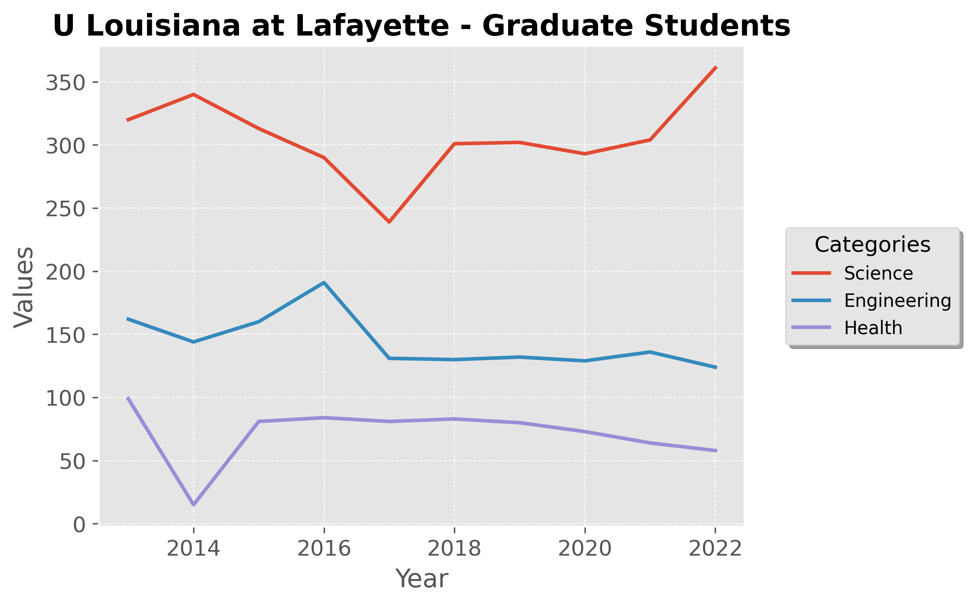

* Science:
  + Science enrollment begins around 300 students in 2014, increasing slightly to a peak of about 350 by 2022. There is a gradual decline from 2016 to 2020, indicating a dip in interest or resources, but a recovery is evident afterward.
  + This pattern suggests sustained interest in science programs with a recent upturn.
* Engineering:
  + Engineering enrollment starts at approximately 150 students in 2014, with a small rise until 2016. Afterward, there is a steady decline, stabilizing around 125 students by 2022.
  + The consistent downward trend may reflect reduced focus or a decline in popularity of engineering programs.
* Health:
  + Health shows lower enrollment, starting at about 100 students in 2014 but dropping to around 50 by 2016. Thereafter, it stabilizes slightly below 50 students and declines slowly through 2022.
  + The minimal and gradually declining enrollment indicates limited interest or offerings in health-related graduate programs.

## Plot 2: Postdoctorates by Category (Science, Engineering, Health)

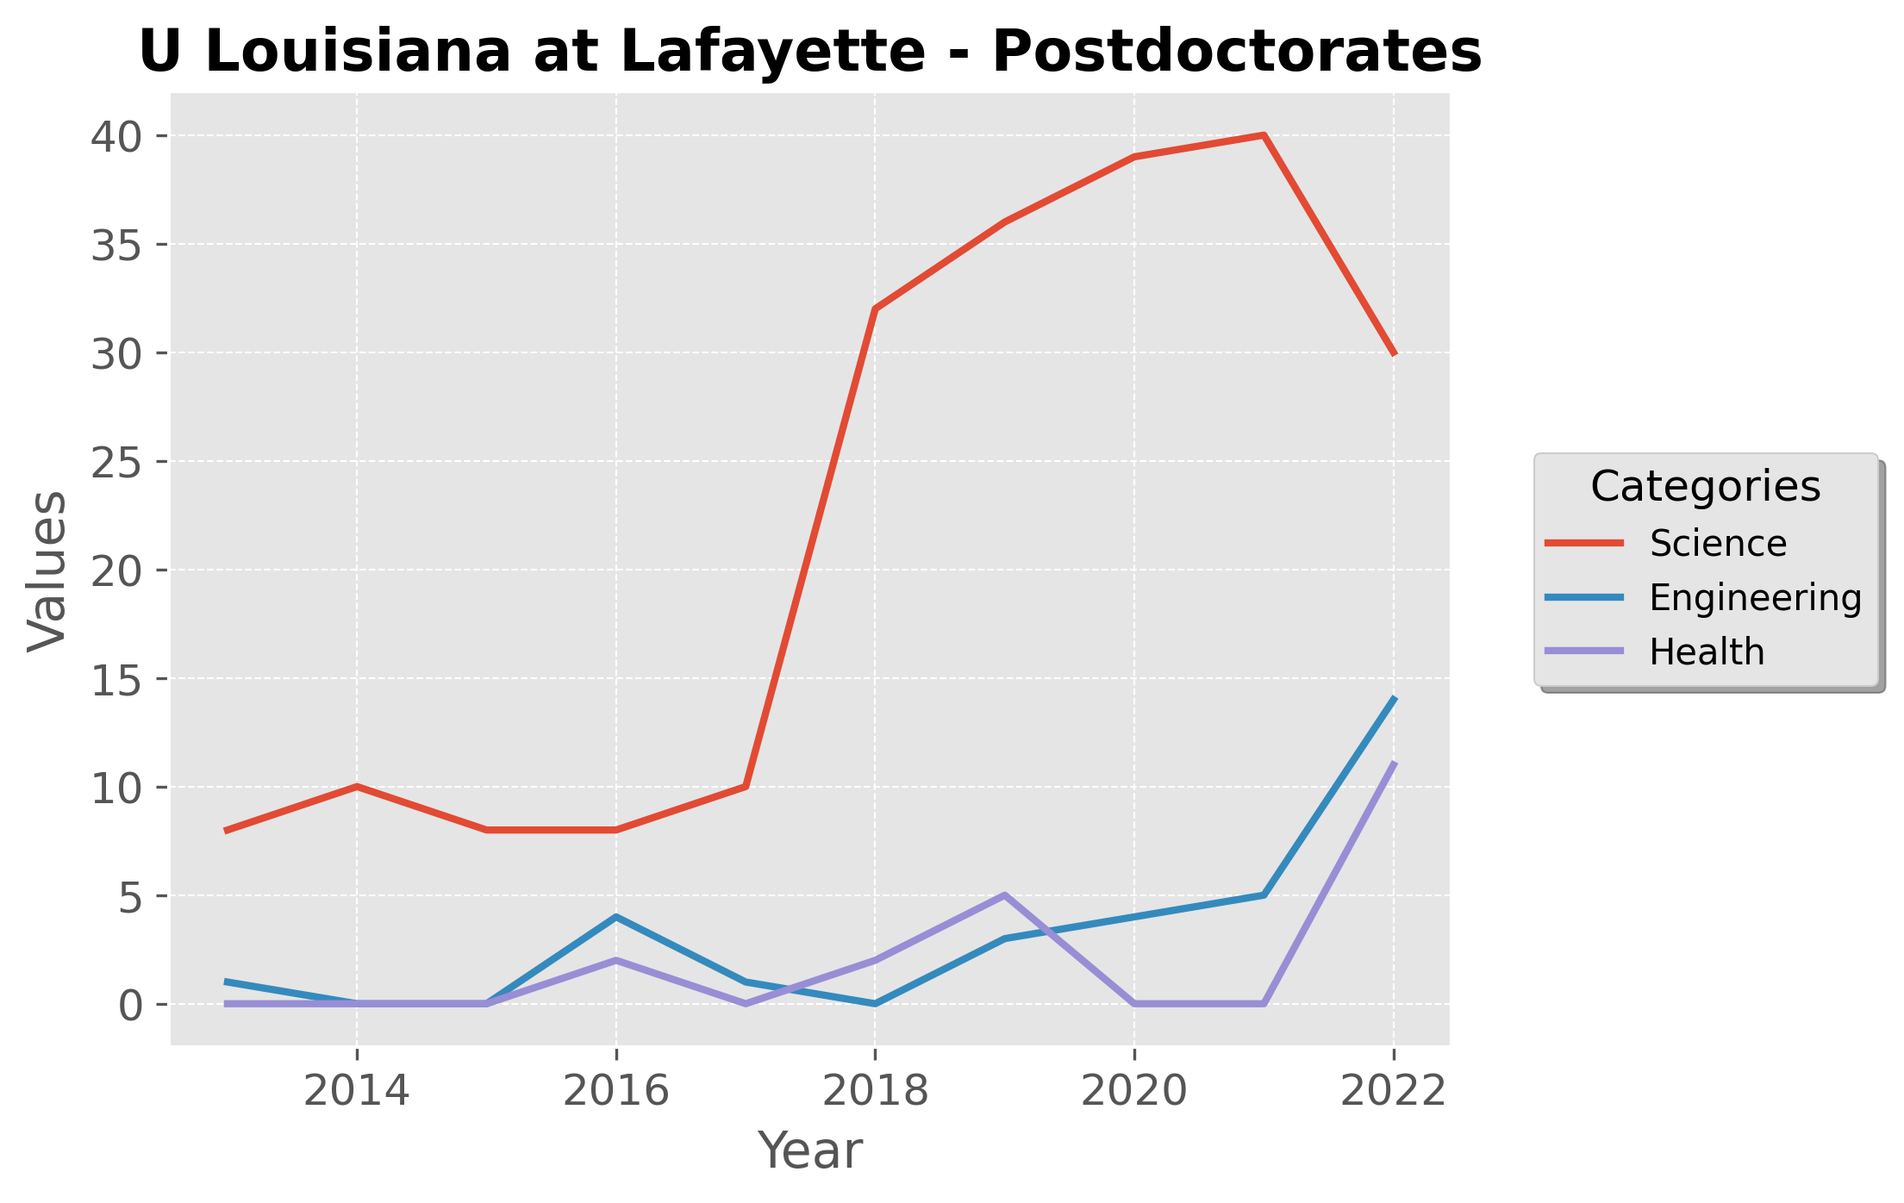

* Science:
  + Science postdoctoral positions are initially low, around 10 positions in 2014, but show a substantial increase, peaking at 40 positions by 2020. After 2020, there’s a drop, bringing the count to around 30 by 2022.
  + The increase and subsequent decrease suggest variability in postdoctoral availability or funding in science.
* Engineering:
  + Engineering postdoc numbers start very low, near 0, but see a gradual increase, reaching around 10 positions by 2022. This steady rise, though small, indicates some growth in postdoctoral opportunities in engineering.
* Health:
  + Health postdoctoral positions are minimal but show a slight increase after 2018, peaking at about 7 positions in 2022. Although low, this upward trend reflects a minor increase in postdoc opportunities in health.

## Plot 3: Funding Sources (Fellowships, Research Assistantships, Teaching Assistantships, Other Support, Personal Resources)

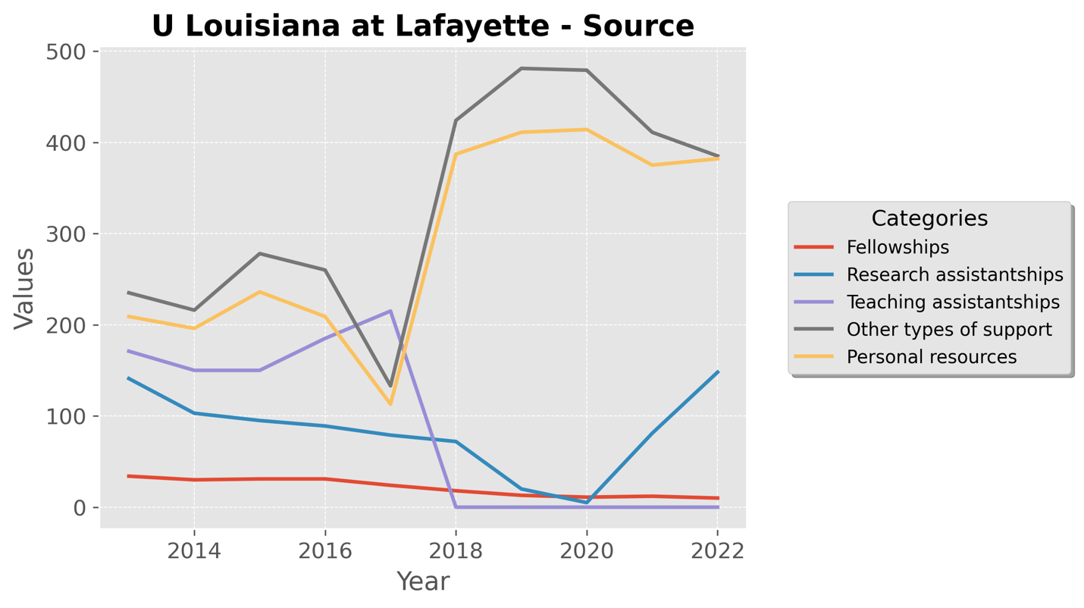

* Other Types of Support:
  + “Other types of support” starts high, around 400 students in 2014, but fluctuates before peaking at over 500 in 2018. Afterward, it declines gradually, stabilizing around 400 by 2022.
  + This category’s variability suggests reliance on fluctuating external or alternative funding sources.
* Personal Resources:
  + Personal resources also begin high, around 300 students in 2014, with a peak in 2018. Afterward, it decreases slightly but remains relatively stable at around 250-300 students.
  + The stability in personal funding indicates a consistent number of self-funded students.
* Research and Teaching Assistantships:
  + Research Assistantships show a declining trend from about 150 students in 2014 to almost 0 by 2020. This decline suggests a shift away from research-based support.
  + Teaching Assistantships remain steady at around 100 students throughout the period, indicating stable teaching support availability.
* Fellowships:
  + Fellowships remain very low across all years, close to 0, indicating limited availability or usage of fellowship funding.

# University Texas San Antionio

## Plot 1: Graduate Students by Category (Science, Engineering, Health)

* Science:
  + Science graduate enrollment starts around 650 students in 2014 with a slight decline up to 2018, followed by an increase reaching nearly 750 students by 2022.
  + This trend suggests a moderate recovery in science program popularity or availability of resources in recent years.
* Engineering:
  + Engineering shows an initial peak around 400 students in 2014, with a steady decline, stabilizing around 200 students by 2020. A slight upward trend is observed from 2020 to 2022.
  + This decline and slight stabilization may indicate shifting interest in engineering or evolving support for this field.
* Health:
  + Health programs have consistently low enrollment, with numbers fluctuating around 50 students throughout the timeline, indicating a minor or limited presence in health-related graduate studies.

## Plot 2: Postdoctorates by Category (Science, Engineering, Health)

* Science:
  + Postdoctoral positions in Science exhibit variation, starting at around 40 positions in 2014 with a sharp peak at 80 in 2018, followed by a gradual decline, stabilizing around 50 by 2022.
  + This fluctuation might indicate variability in postdoctoral funding or available projects within the science programs.
* Engineering:
  + Engineering postdocs maintain a consistently low count, with numbers fluctuating between 10-20 positions across the years, showing minimal growth or focus on engineering postdocs.
* Health:
  + Health postdoctoral positions remain close to 0 throughout the period, reflecting limited postdoctoral opportunities or focus within the health field.

## Plot 3: Funding Sources (Fellowships, Research Assistantships, Teaching Assistantships, Other Support, Personal Resources)

* Other Types of Support:
  + Starting at around 700 students in 2014, “Other types of support” declines gradually, stabilizing around 600 by 2022. This decline may suggest a reduction in alternative or external funding sources over the years.
* Personal Resources:
  + Personal resources begin high at 500 students in 2014, decrease until 2018, then show a steady increase, reaching 600 students by 2022. This suggests an increasing trend of self-funding in recent years.
* Research and Teaching Assistantships:
  + Research assistantships remain stable, around 200-250 students, while teaching assistantships hover between 100-200 students over the years. Both sources show slight growth after 2020, indicating consistent but limited support.
* Fellowships:
  + Fellowships remain consistently low, close to 0 across all years, indicating minimal reliance or availability of fellowship support.

# Northeastern University

## Plot 1: Graduate Students by Category (Science, Engineering, Health)

* Science:
  + Science enrollment starts around 2000 students in 2014 and maintains a steady level until 2016, after which it gradually increases, peaking at about 4000 students in 2022.
  + This consistent rise suggests strong growth and increasing popularity or investment in science graduate programs.
* Engineering:
  + Engineering shows a similar trend, beginning with around 2000 students in 2014 and increasing steadily after 2016, reaching nearly 5000 students by 2022.
  + The rapid growth in the past few years indicates a significant expansion or demand in engineering disciplines at Northeastern.
* Health:
  + Health enrollment remains very low throughout the years, with only a slight increase from 50 to 100 students over the entire period. This minimal growth suggests that health-related graduate studies are a smaller focus.

## Plot 2: Postdoctorates by Category (Science, Engineering, Health)

* Science:
  + Science postdoctoral positions begin around 60 in 2014 and increase to 100 by 2022, showing a steady rise with minor fluctuations.
  + The upward trend indicates a growing interest or availability of postdoctoral opportunities in science.
* Engineering:
  + Engineering postdoc numbers start at around 40 in 2014 and fluctuate moderately, peaking at around 50 before stabilizing near 40 again by 2022. This suggests stable but limited growth in engineering postdoctoral positions.
* Health:
  + Health postdoc positions increase steadily from 20 in 2014 to 60 by 2022, showing continuous growth. This upward trend reflects an expanding focus on postdoctoral roles in health sciences.

## Plot 3: Funding Sources (Fellowships, Research Assistantships, Teaching Assistantships, Other Support, Personal Resources)

* Other Types of Support:
  + “Other types of support” shows significant growth, beginning at about 3000 students in 2014 and rising sharply to over 7000 students by 2022. This increase implies a substantial expansion in alternative funding sources over the years.
* Personal Resources:
  + Personal resources follow a similar trend, also starting around 3000 in 2014 and growing to match other support at around 7000 in 2022. This parallel growth suggests increased self-funding or reliance on personal resources.
* Research and Teaching Assistantships:
  + Research assistantships remain low but steady, with slight growth from 400 to 600 students between 2014 and 2022. Teaching assistantships maintain a similar level, indicating steady support for both types of assistantships.
* Fellowships:
  + Fellowships remain minimal, close to 0 across all years, indicating limited fellowship-based funding support.

# George Mason University

## Plot 1: Graduate Students by Category (Science, Engineering, Health)

* Science:
  + Science graduate enrollment starts around 2000 students in 2014, remains relatively stable with a slight dip around 2018, and then experiences significant growth, reaching over 2500 students by 2022.
  + This trend shows a recent surge in interest or expansion in science programs at George Mason University.
* Engineering:
  + Engineering enrollment remains steady but low, fluctuating around 200-300 students throughout the timeline, with only a minor increase by 2022.
  + The stability at a low level suggests consistent but limited focus or growth in engineering graduate programs.
* Health:
  + Health enrollment is minimal, remaining close to 50 students across all years, with no significant fluctuations. This indicates limited emphasis or interest in health graduate programs.

## Plot 2: Postdoctorates by Category (Science, Engineering, Health)

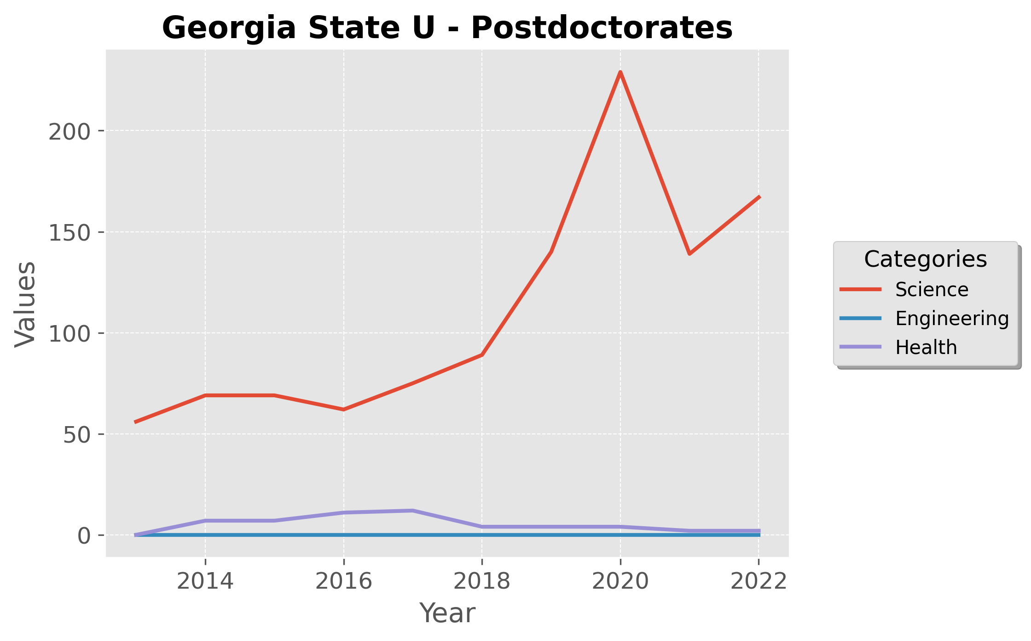

* Science:
  + Science postdoctoral positions show moderate growth, starting at about 30 positions in 2014, experiencing fluctuations, and then rising significantly to around 70 positions by 2022.
  + This increase suggests an expanding focus on postdoctoral roles in science.
* Engineering:
  + Engineering postdoc numbers are low but gradually increase from 5 positions in 2014 to about 20 positions by 2022. This slow but steady growth indicates some focus on enhancing engineering postdoctoral opportunities.
* Health:
  + Health postdoctoral positions are almost negligible, close to 0 throughout the period, reflecting minimal investment in health postdocs.

## Plot 3: Funding Sources (Fellowships, Research Assistantships, Teaching Assistantships, Other Support, Personal Resources)

* Other Types of Support:
  + Starting at around 1500 students in 2014, “Other types of support” sees a gradual decline until 2018, followed by a sharp increase, peaking at over 2000 students by 2022. This suggests a recent influx of alternative funding sources.
* Personal Resources:
  + Personal resources follow a similar trend, beginning at 1000 students in 2014 and experiencing growth to reach around 2000 students by 2022. This indicates a rising reliance on self-funding.
* Research and Teaching Assistantships:
  + Research assistantships remain consistent, slightly increasing from 300 to 400 students over the years. Teaching assistantships are similarly stable, around 200-300 students, indicating steady support from these sources.
* Fellowships:
  + Fellowships remain very low, close to 0 across all years, indicating limited fellowship opportunities.

# Georgia State University

## Plot 1: Graduate Students by Category (Science, Engineering, Health)

* Science:
  + Science graduate enrollment starts around 1700 students in 2014, peaks at approximately 1800 students in 2016, and then declines slightly, stabilizing around 1750 by 2022.
  + The overall trend shows stability with minor fluctuations, indicating consistent interest in science programs over the years.
* Engineering:
  + Engineering enrollment is minimal and remains close to 0 across all years, indicating either a lack of engineering graduate programs or very low interest in this field.
* Health:
  + Health enrollment is steady, fluctuating around 200-250 students throughout the period, suggesting stable but limited emphasis on health-related graduate studies.

## Plot 2: Postdoctorates by Category (Science, Engineering, Health)

* Science:
  + Science postdoctoral positions show growth, starting at about 50 positions in 2014 and peaking dramatically at 200 positions in 2020 before declining to around 150 by 2022.
  + This spike followed by a decrease suggests variability in postdoctoral support or opportunities in science.
* Engineering:
  + Engineering postdoc numbers are minimal and remain close to 0 across all years, indicating limited availability or focus on postdoctoral opportunities in engineering.
* Health:
  + Health postdoctoral positions are similarly low, maintaining values just above 0 with no significant changes, reflecting minimal emphasis on health postdocs.

## Plot 3: Funding Sources (Fellowships, Research Assistantships, Teaching Assistantships, Other Support, Personal Resources)

* Other Types of Support:
  + “Other types of support” starts at around 700 students in 2014, showing gradual growth to over 1000 students by 2022. This steady rise indicates a stable increase in alternative funding options.
* Personal Resources:
  + Personal resources show an upward trend, beginning at 500 students in 2014 and growing to around 800 by 2022. This increase suggests a rising reliance on self-funded students.
* Research and Teaching Assistantships:
  + Research assistantships remain stable, around 800 students, indicating consistent availability. Teaching assistantships show more variability, starting at 600, peaking in 2016, and then decreasing to around 500 by 2022.
* Fellowships:
  + Fellowship funding starts low, around 150 students in 2014, and declines slightly over time, stabilizing near 100 by 2022.

# Temple University

## Plot 1: Graduate Students by Category (Science, Engineering, Health)

* Science:
  + Science graduate enrollment starts around 1000 students in 2014, peaks at approximately 1200 in 2016, and remains stable before experiencing a slight decline, ending close to 1000 in 2022.
  + The trend indicates a period of growth followed by stability and a minor decrease in recent years.
* Engineering:
  + Engineering enrollment remains consistently low, close to 100 students or less throughout the timeline, suggesting limited growth or focus in this field.
* Health:
  + Health enrollment is also low, with slight fluctuations between 100-200 students, declining to near 0 by 2022. This pattern suggests reduced interest or support for health graduate programs at Temple University.

## Plot 2: Postdoctorates by Category (Science, Engineering, Health)

* Science:
  + Science postdoctoral positions show variability, starting at around 100 positions in 2014, peaking at 120, and then declining gradually, ending near 90 in 2022.
  + The pattern suggests stable interest in science postdocs with minor declines over time.
* Engineering:
  + Engineering postdoc numbers are low, consistently below 20 positions across the years, reflecting limited availability or demand for postdoctoral roles in engineering.
* Health:
  + Health postdoctoral roles show a gradual increase, starting near 50 in 2014 and reaching 60 by 2022. This steady rise indicates a growing focus on health-related postdoctoral opportunities.

## Plot 3: Funding Sources (Fellowships, Research Assistantships, Teaching Assistantships, Other Support, Personal Resources)

* Other Types of Support:
  + “Other types of support” shows an initial growth from around 600 in 2014 to over 800 by 2018, followed by a decline to around 700 by 2022. This suggests variability in external or alternative funding.
* Personal Resources:
  + Personal resources increase from around 500 in 2014 to 800 by 2018, then gradually decline, stabilizing around 600 by 2022. This indicates a fluctuating reliance on self-funding.
* Research and Teaching Assistantships:
  + Research assistantships show consistent growth, starting at 300 and reaching around 400 by 2022. Teaching assistantships fluctuate between 300-400, suggesting stable but limited growth.
* Fellowships:
  + Fellowships remain low, around 100, with minimal changes across all years, indicating limited fellowship-based support.

# University Notre Dame

## Plot 1: Graduate Students by Category (Science, Engineering, Health)

* Science:
  + Science graduate enrollment starts around 900 students in 2014, with steady growth reaching approximately 1000 students by 2022.
  + This gradual increase reflects a stable and consistent interest or expansion in science graduate programs.
* Engineering:
  + Engineering enrollment shows continuous growth, beginning at around 400 students in 2014 and rising to over 600 students by 2022.
  + This trend suggests a strengthening focus or increasing demand for engineering programs at Notre Dame.
* Health:
  + Health enrollment remains minimal and stable, hovering below 50 students throughout the period, indicating limited focus or demand in health-related graduate studies.

## Plot 2: Postdoctorates by Category (Science, Engineering, Health)

* Science:
  + Science postdoctoral positions exhibit a declining trend, starting at 120 positions in 2014 and decreasing to around 80 positions by 2022.
  + This steady decline may reflect a reduction in postdoctoral funding or opportunities within science.
* Engineering:
  + Engineering postdocs show moderate fluctuations, beginning at 60 positions in 2014 and maintaining this range with minor ups and downs, stabilizing around 50 positions by 2022.
  + The consistency suggests stable but limited growth in postdoctoral roles in engineering.
* Health:
  + Health postdoctoral positions are negligible, remaining close to 0 across all years, showing little to no postdoctoral emphasis in health.

## Plot 3: Funding Sources (Fellowships, Research Assistantships, Teaching Assistantships, Other Support, Personal Resources)

* Research Assistantships:
  + Research assistantships are the most significant funding source, starting around 600 in 2014 and increasing steadily, peaking close to 700 by 2022. This trend indicates robust support through research positions.
* Teaching Assistantships:
  + Teaching assistantships begin at 300 students in 2014 and fluctuate, reaching a peak of around 400 in 2020 before stabilizing around 350 by 2022. This shows steady availability with minor variations.
* Fellowships:
  + Fellowships show variability, starting at 250 in 2014, peaking at 500 in 2020, and then declining to around 400 by 2022. This suggests fluctuating fellowship availability over the years.
* Other Types of Support:
  + Other support sources are stable at around 200, with minor increases by 2022. This consistency indicates reliance on alternative funding sources at a moderate level.
* Personal Resources:
  + Personal resources are minimal but increase slightly over time, from around 100 in 2014 to 150 by 2022, indicating a minor rise in self-funding among students.

# Florida International University

## Plot 1: Graduate Students by Category (Science, Engineering, Health)

* Science:
  + Science graduate enrollment starts around 1000 students in 2014, sees a notable increase to approximately 1300 by 2016, then stabilizes before growing to around 1400 by 2022.
  + This steady increase reflects ongoing growth and strengthening interest or investment in science programs at Florida International University.
* Engineering:
  + Engineering enrollment remains stable, starting at about 400 students in 2014 and gradually increasing to around 500 by 2022.
  + The slow and steady growth suggests consistent support for engineering programs, though at a moderate level compared to science.
* Health:
  + Health enrollment shows slight growth, starting near 200 students in 2014 and rising gradually to approximately 300 by 2022.
  + This indicates a stable but modest emphasis on health-related graduate studies.

## Plot 2: Postdoctorates by Category (Science, Engineering, Health)

* Science:
  + Science postdoctoral positions grow significantly from around 50 positions in 2014 to nearly 180 by 2022. There is a rapid increase up to 2018, after which the numbers level off.
  + This sharp growth suggests a substantial increase in postdoctoral opportunities or funding within the science field.
* Engineering:
  + Engineering postdocs show gradual growth, from around 10 positions in 2014 to approximately 30 by 2022. The growth is steady but limited compared to science.
  + This indicates consistent but lower demand or availability of engineering postdoctoral roles.
* Health:
  + Health postdoctoral positions remain low, with minimal increases, growing from close to 5 in 2014 to around 15 by 2022.
  + This reflects limited postdoctoral emphasis in health at Florida International University.

## Plot 3: Funding Sources (Fellowships, Research Assistantships, Teaching Assistantships, Other Support, Personal Resources)

* Other Types of Support:
  + “Other types of support” sees significant growth, starting around 600 in 2014 and peaking sharply at 1300 by 2016, followed by fluctuations and reaching around 1400 by 2022.
  + This trend suggests substantial reliance on alternative funding, with a peak period around 2016.
* Personal Resources:
  + Personal resources exhibit similar growth, also peaking near 1300 by 2016, then stabilizing around 1200-1300 in subsequent years.
  + This indicates a strong reliance on self-funding or personal contributions for student support.
* Research and Teaching Assistantships:
  + Research assistantships are stable, starting around 200 and showing minor growth to about 300 by 2022. Teaching assistantships follow a similar trend, peaking around 400 in 2016 before leveling off at 300.
  + The stability in these categories suggests consistent, albeit moderate, support for students via assistantships.
* Fellowships:
  + Fellowships remain relatively low, starting near 50 in 2014 and growing modestly to around 100 by 2022.
  + This reflects limited but gradually increasing availability of fellowship-based funding.

# University of Dayton

## Plot 1: Graduate Students by Category (Science, Engineering, Health)

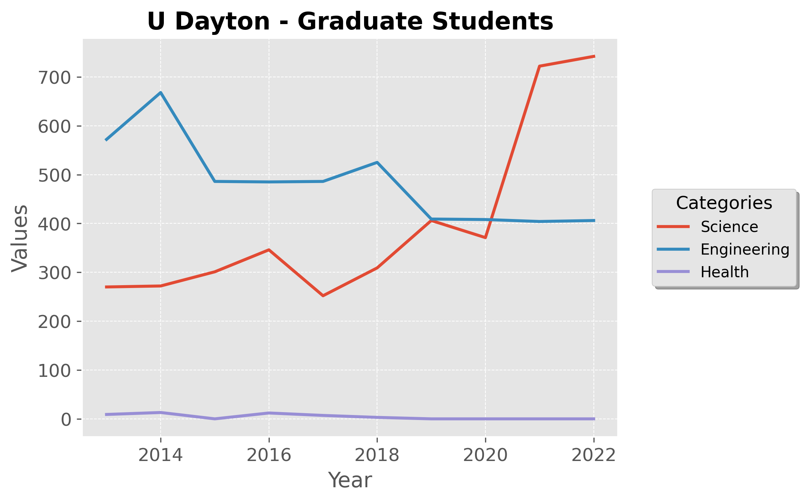

* Science:
  + Science graduate enrollment shows gradual growth, starting around 300 students in 2014 and then sharply increasing to over 700 students by 2022.
  + This significant growth in recent years suggests a strengthening focus or rising interest in science programs.
* Engineering:
  + Engineering enrollment fluctuates, beginning at 600 students in 2014, peaking early, then stabilizing around 500 and finally dipping slightly by 2022.
  + This trend indicates a consistent but slightly decreasing interest or availability in engineering programs.
* Health:
  + Health enrollment remains minimal and stable, with values close to 50 students across all years, indicating limited focus or demand for health-related graduate studies.

## Plot 2: Postdoctorates by Category (Science, Engineering, Health)

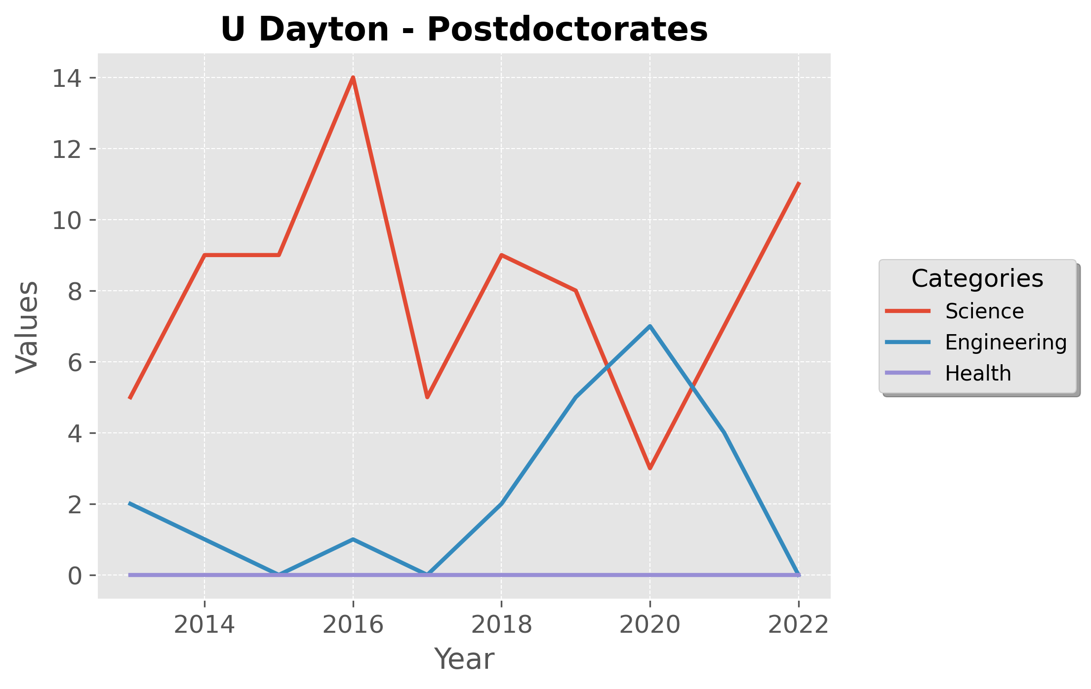

* Science:
  + Science postdoctoral positions show fluctuations, peaking at 15 positions around 2016, then decreasing and rising again by 2022 to about 10.
  + The variability suggests shifting priorities or funding levels for science postdocs at U Dayton.
* Engineering:
  + Engineering postdoctoral roles are low, beginning close to 0 in 2014, then fluctuating with a peak around 5 in 2020 before decreasing again.
  + The minimal numbers reflect limited growth or emphasis on engineering postdoctoral opportunities.
* Health:
  + Health postdoctoral positions are consistently 0 across all years, indicating no dedicated postdoctoral opportunities in health fields.

## Plot 3: Funding Sources (Fellowships, Research Assistantships, Teaching Assistantships, Other Support, Personal Resources)

* Other Types of Support:
  + “Other types of support” remains the highest category, fluctuating around 600-800 students from 2014 to 2020, with a sharp increase reaching over 1000 by 2022.
  + This increase indicates substantial reliance on alternative funding sources.
* Personal Resources:
  + Personal resources show a similar trend to other support, with a stable range around 600-800 students, peaking over 1000 by 2022.
  + The pattern suggests a growing reliance on self-funding for graduate studies.
* Research and Teaching Assistantships:
  + Research and teaching assistantships remain low and stable, each fluctuating slightly around 100-200 students across the timeline, indicating consistent but limited availability of these funding options.
* Fellowships:
  + Fellowships are minimal, close to 0 across all years, showing limited availability of fellowship-based funding at U Dayton.